Question 21:

CODE:

%{

#include <stdio.h>

%}

%%

[A-Z]+ { printf("Capital Word: %s\n", yytext); }

. { /* Ignore other characters */ }

%%

int main() {

yylex();

return 0;

}

int yywrap() {

return 1;

}

OUTPUT:

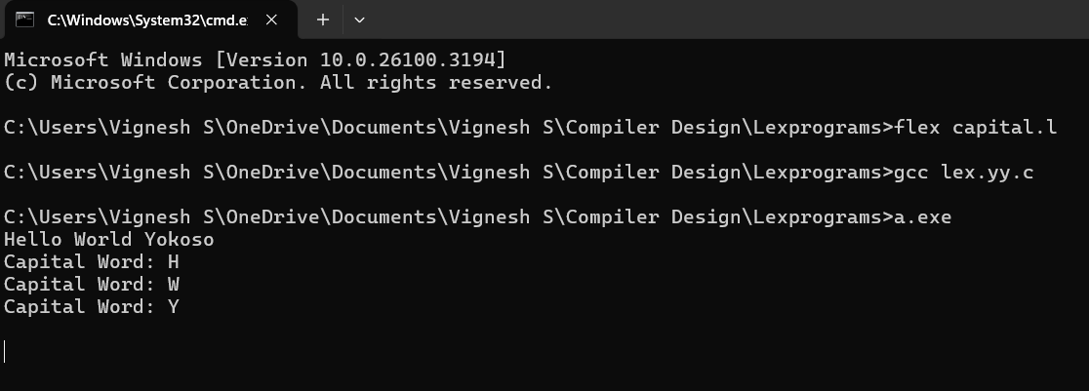

Question 22:

CODE:

%{

#include <stdio.h>

%}

%%

^[a-zA-Z0-9._%+-]+@[a-zA-Z0-9.-]+\.[a-zA-Z]{2,}$ { printf("Valid Email: %s\n", yytext); }

.* { printf("Invalid Email: %s\n", yytext); }

%%

int main() {

printf("Enter an email: ");

yylex();

return 0;

}

int yywrap() {

return 1;

}

OUTPUT:

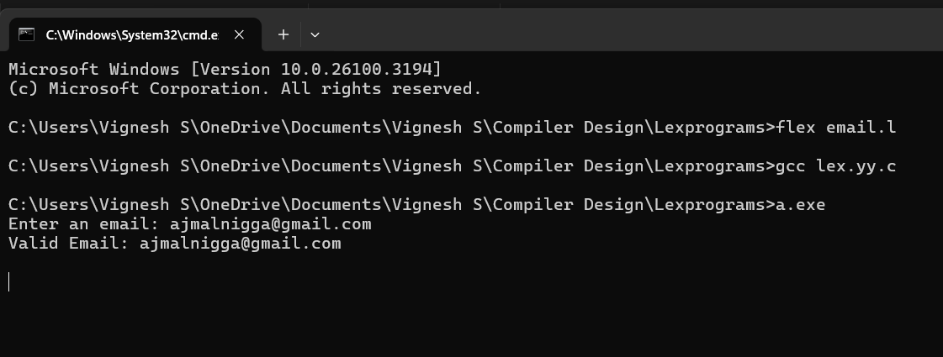

Question 23:

CODE:

%{

#include <stdio.h>

%}

%%

[789][0-9]{9} { printf("Valid Mobile Number: %s\n", yytext); }

. { /* Ignore other characters */ }

%%

int main() {

yylex();

return 0;

}

int yywrap() {

return 1;

}

OUTPUT:

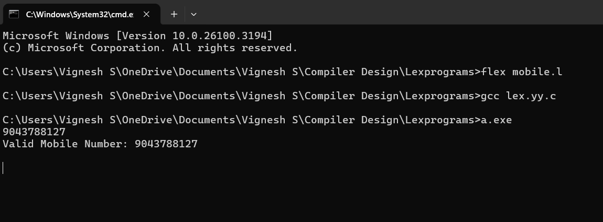

Question 24:

CODE:

%{

#include <stdio.h>

int vowel_count = 0;

%}

%%

[AEIOUaeiou] { vowel_count++; }

. { /* Ignore other characters */ }

\n { printf("Number of vowels: %d\n", vowel_count); vowel_count = 0; }

%%

int main() {

yylex();

return 0;

}

int yywrap() {

return 1;

}

OUTPUT:

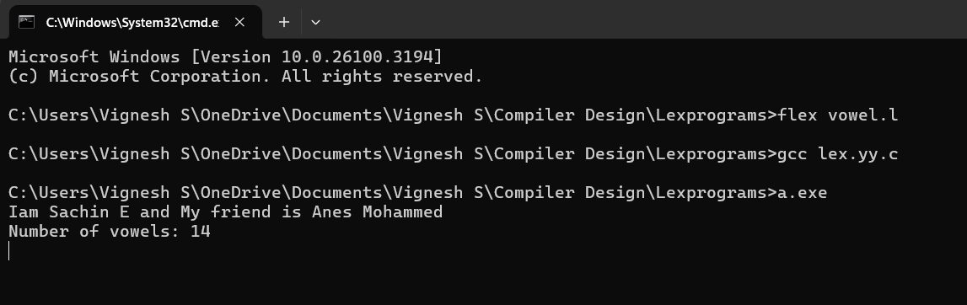

Question 25:

CODE:

%{

#include <stdio.h>

%}

%%

[0-9] { printf("Digit: %s\n", yytext); }

. { printf("Not a digit: %s\n", yytext); }

%%

int main() {

yylex();

return 0;

}

int yywrap() {

return 1;

}

OUTPUT:

